|  |  |  |  |  |
| --- | --- | --- | --- | --- |
|  | **Title :** **Project Registration & Progress Review** | | **FF No. 180** |  |
|  | | | | | |
|  | | | | | |
| **Department:** Computer Engineering | | **Academic Year:** 2024-25 | | | |
| **Semester:** I | | **Group No. :82** | | | |
| **Project Title:** SYVIX: A UNIX Based Operating System Implementation | | | | | |
| **Project Area:** Operating System, System Programming | | | | | |
| **Group Members Details:** | | | | | |

|  |  |  |  |  |  |  |
| --- | --- | --- | --- | --- | --- | --- |
| Sr. No. | Class & Div. | Roll No. | G.R.No. | Name of Student | Contact No. | Email ID |
| 1 | CS-D | 76 | 12210194 | Vipra | 9596601847 | undefined.vipra22@vit.edu |
| 2 | CS-D | 83 | 12210302 | Ishan Yadav | 8999004684 | ishaan.yadav22@vit.edu |
| 3 | CS-D | 84 | 12210596 | Shriraj Yamkanmardi | 9028746276 | shriraj.yamkanmardi22@vit.edu |
| 4 | CS-D | 86 | 12211472 | Yash Maheshwari | 9552511300 | yash.maheshwari22@vit.edu |
|  |  |  |  |  |  |  |
|  |  |  |  |  |  |  |

|  |
| --- |
| Name of Internal Guide: Dr. Shital Phatangare Contact No. & Email ID: shital.phatangare@vit.edu |

|  |
| --- |
| Project approved / Not approved  Prof. Prof. Ranjeetsingh Suryawanshi Prof.(Dr) Sandip Shinde  **Guide Project Coordinator Head,**  **Department of Computer Engineering** |

T

**FF No** **180**

**Project Synopsis**

* **Introduction:**

The mother of all operating system named UNIX is the first of all modern day operating system made in 1972 which is still working in many of the industrial areas, understanding its architecture and its actual functionality and making changes in it according to modern day requirements is our main aim. We are trying to implement algorithms present in UNIX operating system which serves as backend and which help system to carry out all the procedure of File System and Process Subsystem. The guidance for this project is taken from book named "The UNIX Operating System" By Mauris J. Bach [1]

* **Problem Statement:**

We all are using computer on daily basis extensively but we lack in the area of using computer neatly and using it at its best. We all know that whole performance of our system is completely reliable on Operating System. Knowing the insights of this operating system can help us to use the system efficiently and can prevent us from its hazardous use. Also implementing these all algorithms in core system programming language called C can help us to know more about C and expand its usage hugely

* **Objectives:**

**Enhance Algorithmic Understanding:**

1. **Objective:** Implement a diverse set of algorithms in C to deepen understanding of their underlying principles and operations.

**Explanation:** By coding different algorithms, you’ll gain insight into their complexities, trade-offs, and performance characteristics, which can help in mastering algorithm design and analysis.

**Optimize Performance and Resource Usage:**

1. **Objective:** Explore and implement optimization techniques to improve the performance and resource utilization of the algorithms.

**Explanation:** C is known for its efficiency and low-level control, so by optimizing algorithms, you’ll learn to write high-performance code and manage resources effectively.

1. **Objective:** Gain a deeper understanding of the UNIX operating system by implementing algorithms in C and exploring system-level programming concepts.

**Explanation:** By coding algorithms and system-level applications in C, you’ll interact with UNIX's core functionalities, such as process management, file systems, and inter-process communication.

Develop a user-friendly dashboard accessible to parents and educators, providing real-time updates on a child's progress, strengths, and areas for improvement.

**FF No** **180**

**Project Synopsis**

* **Literature review:**

Design of UNIX Operating System :- By Maurice J. Bach

Ref=https://books.google.co.in/books/about/The_Design_of_the_UNIX_Operating_System.html? [1]

Lion’s Commentary on UNIX Operating System(SIXTH EDITION) Ref=https://cs3210.cc.gatech.edu/r/unix6.pdf [2] Artificial intelligence in early childhood[2]

* **System architecture:**

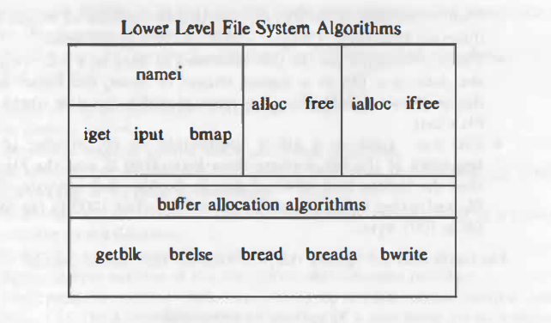

**FF No** **180**

|  |  |  |  |
| --- | --- | --- | --- |
| Group No. |  | | |
| Activity | Review Schedule | Progress Review Report submitted | Signature of Guide |
| Review 1 | Mid Sem. Semester | Yes / No |  |
| Review 2 | End of Semester | Yes / No |  |

Format of Progress Review Report:

|  |
| --- |
| **Review No.: 1 Group No.: Date:** |
| **Progress Review Report** |
| **Signature of Guide:** |

**FF No** **180**

|  |
| --- |
| **Review No.: 2 Group No.: Date:** |
| **Progress Review Report** |
| **Signature of Guide:** |